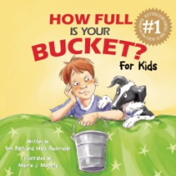
For the month of February, the book (or version of the book) that the GATE staff discussed with students was: “How Full Is Your Bucket”, by Tom Rath and Mary Reckmeyer.
Now you might say,” What does “filling buckets” have to do with being gifted, or learning, or even education????” That’s a great question, so let me explain!

First, I heard about the adult book, “How Full is Your Bucket?” by Tom Rath and Dr. Donald Clifton. The
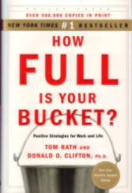
following is a description of this book:

How did you feel after your last interaction with another person?
Did that person -- your spouse, best friend, coworker, or even a stranger -- "fill your bucket" by making you feel more positive? Or did that person "dip from your bucket," leaving you more negative than before?
The #1 New York Times and #1 BusinessWeek bestseller, How Full Is Your Bucket? reveals how even the briefest interactions affect your relationships, productivity, health, and longevity. Organized around a simple metaphor of a dipper and a bucket, and grounded in 50 years of research, this book will show you how to greatly increase the positive moments in your work and your life -- while reducing the negative.
Filled with discoveries, powerful strategies, and engaging stories, How Full Is Your Bucket? is sure to inspire lasting changes and has all the makings of a timeless classic.

After hearing about this book, I heard that this same author, and other authors, came out with some “children’s versions”, so we decided to share those with our students.
The elementary students were read the book: “How Full Is Your Bucket?” A synopsis of this book is below.

This charming book explains to children how being kind not only helps others, it helps them, too.
In the story, you meet a little boy named Felix. As he goes about his day, Felix interacts with different people — his sister Anna, his grandfather, other family and friends. Some people are happy, but others are grumpy or sad. Using the metaphor of a bucket and dipper, Felix’ grandfather explains why the happy people make Felix feel good, while the others leave him feeling bad — and how Felix himself is affecting others, whether he means to or not. This beautifully illustrated adaptation takes the original book’s powerful message — that the way we relate to others has a profound effect on every aspect of our lives — and tailors it to a child’s unique needs and level of understanding.

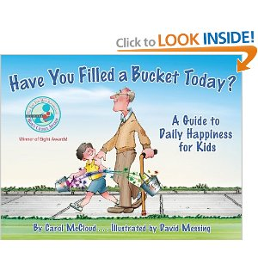
Another book that is available is “Have You Filled a Bucket Today?”, also shares the importance of encouraging positive behavior as children see how rewarding it is to express daily kindness, appreciation, and love. Bucket filling and dipping are effective metaphors for understanding the effects of our actions and words on the well being of others and ourselves.

Carol McCloud, co-author of “Have You Filled a Bucket Today?”, and also known affectionately as “the Bucket Lady”, is an early childhood specialist, educator, and popular international speaker. Carol understands that a healthy self-concept starts very early in life and is fostered by others. As president of Bucket Fillers, Inc., an educational organization in Brighton, Michigan, her team mission is to create bucket-filling schools, families, and communities, where everyone is respected, honored, and valued.
The reason we wanted to share this “bucket filling” concept with your children is that many times, we don’t feel that all children are feeling valued, and if we want to change that, we need to start now!! Our gifted and talented students can be the leaders, in not only academics, art, music, but in respectful and honorable behavior as well!! Our GATE students can be challenged to lead the way in their schools to show how they value ALL students and staff! The students can lead by example and their strong values of respect can, and will, be like a “wave” that splashes onto all of the school community! With “bucket filling” and our PBIS initiatives at all schools, the GATE students will “Rock the District” with responsible leadership and a caring spirit!!!

We hope the bucket filling that occurs at school will also occur in your homes!! There is no greater joy than to hear something positive, to get a smile or hug from someone who cares, to get help, a pat on the back, AND to give all of the same to someone else!!
Thank you for all of the ways that you fill our buckets, and for the opportunity to work with your children each week. Their excitement about learning is constant “filler” for us!!

We have included a link to a site that has a plethora of free and age-appropriate materials on “bucket-filling. It also lists other books on this topic.
http://www.bucketfillers101.com/

